Upper Respiratory Infection (URI)
An Upper Respiratory Infection, or URI, is a contagious illness similar to the common cold in humans. It is spread between cats via several different airborne viruses and is common in shelter or kennel environments. Upper Respiratory Infections are often complicated by a secondary bacterial infection which requires antibiotics to treat.

Common Symptoms:  - Frequent sneezing  - Nasal discharge which can vary from clear-colored to thick, green-yellow  - Eye discharge or squinting eyes  - Lack of appetite  - Congestion | When to alert Foster Department:  - Any symptoms worsen  - Has not eaten in 24 hours (adult cat) or 12 hours (kitten)  - Notable decrease in energy level or lethargic behavior  - Wheezing or trouble breathing  - Swelling of the eyeball or inner eyelid  - Cloudy pupil(s)

Pay attention when cleaning your foster animal’s litterbox to ensure they are regularly defecating and urinating; a sign that they are eating and drinking.

Is an Upper Respiratory Infection contagious?
Yes, an Upper Respiratory Infection is contagious to other cats, but not to humans or other pets such as dogs. Any time you bring a foster animal into your home, your household pets are at risk of contracting an illness. To minimize the risk of your resident cats(s) contracting a URI we recommend keeping them up to date on vaccines. However, since more than one virus can cause a URI, this is not guaranteed to protect them. You should keep foster cats with a URI in a separate area of the home from your resident cat(s) and wash your hands in between handling them. Never allow your foster cat(s) to share food or water bowls, toys, or bedding with your resident cat(s) if they have a URI.
Tips for administering medication
- Your foster animal may be provided with liquid oral antibiotics and/or optical medication for their eyes.
- Note each time you give your foster medication on the med chart provided in your packet. Medications should be given at approximately the same time daily.
- It is important to finish all of the medication provided even if your foster animal’s symptoms improve.
- To administer oral medication: grasp the cat’s head/face gently, but firmly enough to hold them in place, use your thumb and index finger to gently squeeze the sides of the cat’s mouth to open it, place the tip of the syringe into their mouth, but not into their throat, and quickly administer the medication. (See photo below)
- To administer eye medication: with one hand grasp the cat’s head from underneath their chin gently, but firmly enough to hold them in place, use your other hand to gently lift the cat’s eye open, and squeeze the medication directly into the cat’s eye without touching the applicator to the eye. (See photo below)
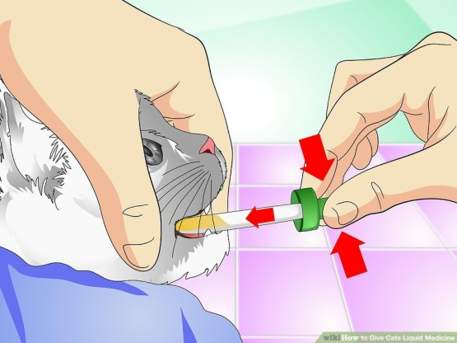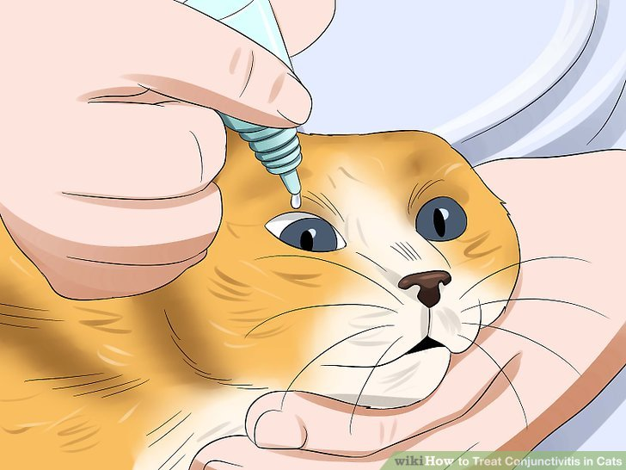
Oral medication Eye medication
In order to keep your foster animal comfortable and have a speedy recovery
- Monitor their food and water intake- Your foster animal may have a lack of appetite so offer a variety of foods to peak their interest. You can mix kibble with canned food, try different types of canned food, or add meat-flavored baby food, canned tuna, or canned chicken. Heating up their food can also help!
- Minimize stress- Keep your foster animal set up in a warm, comfortable area of your home where they can get plenty of rest.
- Warm compress- Wet a hand towel with warm (not hot!) water and hold it onto your foster animal’s eyes for approximately 30 seconds to loosen any dried, crusty discharge to keep them clean and open.
- Humidify- Use your bathroom to help soothe sore air passageways. Turn the shower on hot, close any doors and windows to allow the room to become steamy, and place your foster animal into the bathroom (not in the shower) for 10 minutes at a time.
Remember to contact the SSPCA Foster Department to schedule a vet recheck BEFORE you get to the end of your foster animal’s medication!

